**BANK LOAN REPORT SQL QUERY**

# **KPI’s:**

## Total Loan Applications

SELECT COUNT(id) AS Toatal_Loan_Application FROM Bank_Loan_Data



## MTD Loan Application

SELECT COUNT(id) AS MTD_Total_Applications FROM Bank_Loan_Data

WHERE MONTH(issue_date) = 12 AND YEAR(issue_date) = 2021



### PMTD Loan Application

SELECT COUNT(id) AS PMTD_Applications FROM Bank_Loan_Data

WHERE MONTH(issue_date) = 11 AND YEAR(issue_date) = 2021

### GROUP BY MONTH(issue_date)



### MTD Loan Application Each Month

SELECT

MONTH(issue_date) AS Month,

COUNT(id) AS MTD_Total_Applications

FROM

Bank_Loan_Data

WHERE

YEAR(issue_date) = 2021

AND DAY(issue_date) <= CASE

WHEN MONTH(issue_date) = MONTH(GETDATE()) THEN DAY(GETDATE())

ELSE DAY(EOMONTH(issue_date))

END

GROUP BY

MONTH(issue_date)

ORDER BY

MONTH(issue_date)

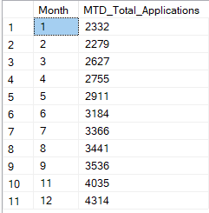

### Total_Funded_Amount

SELECT SUM(loan_amount) AS Total_Funded_Amount FROM Bank_Loan_Data



### MTD Total Funded Amount

SELECT SUM(loan_amount) AS MTD_Total_Funded_Amount FROM Bank_Loan_Data

WHERE MONTH(issue_date) = 12 AND YEAR(issue_date) = 2021



### Total Amount Recived

SELECT SUM(total_payment) AS Total_Amount_Recived FROM Bank_Loan_Data



### MTD Amount Recived

SELECT SUM(total_payment) AS MTD_Amount_Recived FROM Bank_Loan_Data

WHERE MONTH(issue_date) = 12 AND YEAR(issue_date) = 2021



### Average Interest Rate

SELECT ROUND(AVG(int_rate),4)*100 AS Average_Interest_Rate FROM Bank_Loan_Data

### MTD Average Interest Rate

SELECT ROUND(AVG(int_rate),4)*100 AS Average_Interest_Rate FROM Bank_Loan_Data

WHERE MONTH(issue_date) = 11 AND YEAR(issue_date) = 2021



### PMTD Average Interest Rate

SELECT AVG(int_rate)*100 AS Average_Interest_Rate FROM Bank_Loan_Data

## WHERE MONTH(issue_date) = 11 AND YEAR(issue_date) = 2021



### Average Debt to Income Ratio (DTI)

SELECT ROUND(AVG(dti),4)*100 AS Average_DTI FROM Bank_Loan_Data



### Average MTD Debt to Income Ratio

SELECT ROUND(AVG(dti),4)*100 AS Average_DTI FROM Bank_Loan_Data

WHERE MONTH(issue_date) = 11 AND YEAR(issue_date) = 2021



## Good Loan vs Bad loan KPIs

### Distinct loan status

SELECT DISTINCT(loan_status) FROM Bank_Loan_Data

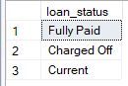

### Good Loan Percentage

SELECT

(COUNT(CASE WHEN loan_status ='Fully Paid' or loan_status ='Current' THEN id END)*100)

/

COUNT(id) AS Good_loan_percentage

FROM Bank_Loan_Data



### Good Loan Applications

SELECT COUNT(id) AS Good_loan_applications FROM Bank_Loan_Data

WHERE loan_status ='Fully Paid' or loan_status= 'Current'



### Total amount of funds disbursed as good loan

SELECT SUM(loan_amount) AS Good_loan_disbursment FROM Bank_Loan_Data

### WHERE loan_status ='Fully Paid' or loan_status= 'Current'

### 

### Total amount received from good loans

SELECT SUM(total_payment) AS Good_loan_amount_recived FROM Bank_Loan_Data

### WHERE loan_status ='Fully Paid' or loan_status= 'Current'

### 

### Bad Loan Percentage

SELECT

(COUNT(CASE WHEN loan_status ='Charged off' THEN id END)*100)

/

COUNT(id) AS Bad_loan_percentage

### FROM Bank_Loan_Data

### 

### Bad Loan Applications

SELECT COUNT(id) AS Bad_loan_applications FROM Bank_Loan_Data

### WHERE loan_status ='Charged Off'

### 

### Total amount of funds disbursed as bad loan

SELECT SUM(loan_amount) AS Bad_loan_disbursement FROM Bank_Loan_Data

WHERE loan_status ='Charged Off'



### Total amount received from bad loans

SELECT SUM(total_payment) AS Bad_loan_amount_recived FROM Bank_Loan_Data

WHERE loan_status ='Charged Off'



## Loan status grid

SELECT

loan_status,

COUNT(id) AS Loan_Count,

SUM(loan_amount) AS Total_Funded_Amount,

SUM(total_payment) AS Total_Amount_Received,

ROUND(AVG(int_rate),4)*100 AS Interest_Rate,

ROUND(AVG(dti),4)*100 AS DTI

FROM

Bank_Loan_Data

GROUP BY

loan_status

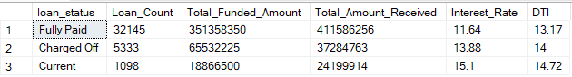

### Month-to-date Amount Funded and Received Table

SELECT

loan_status,

SUM(total_payment) AS MTD_Amount_Recived,

SUM(loan_amount) AS MTD_Total_Funded_Amount

FROM Bank_Loan_Data

WHERE MONTH(issue_date) = 12

GROUP BY loan_status

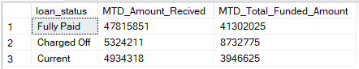

### MTD Total Applications for Each Month

SELECT

MONTH(issue_date),

DATENAME(MONTH, issue_date) AS Month_Name,

COUNT(id) AS Total_loan_applications,

SUM(total_payment) AS MTD_Amount_Recived,

SUM(loan_amount) AS MTD_Total_Funded_Amount

FROM Bank_Loan_Data

GROUP BY MONTH(issue_date), DATENAME(MONTH, issue_date)

ORDER BY MONTH(issue_date)

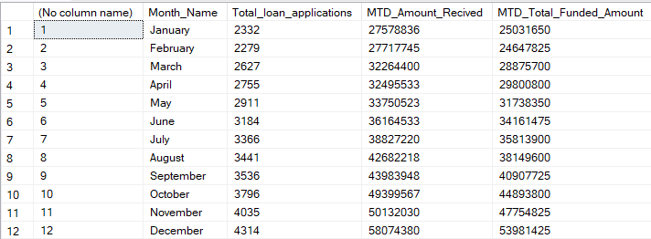

### Total Applications for Each State with Total Amount Funded vs Received

SELECT

address_state,

COUNT(id) AS Total_loan_applications,

SUM(total_payment) AS Total_Amount_Recived,

SUM(loan_amount) AS Total_Funded_Amount

FROM Bank_Loan_Data

GROUP BY address_state

ORDER BY SUM(loan_amount) DESC

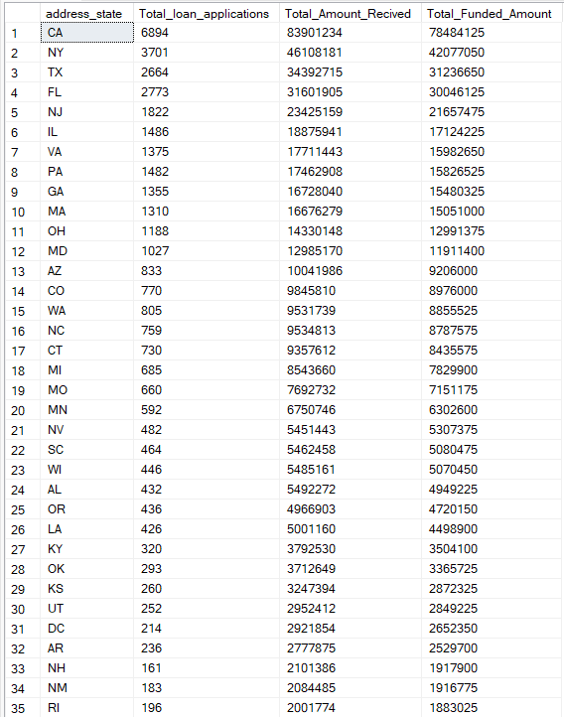

### Total Applications for each team

SELECT

term,

COUNT(id) AS Total_loan_applications,

SUM(total_payment) AS Total_Amount_Recived,

SUM(loan_amount) AS Total_Funded_Amount

FROM Bank_Loan_Data

GROUP BY term

ORDER BY SUM(loan_amount)



### Total Loan Applications based on Employment Length

SELECT

emp_length,

COUNT(id) AS Total_loan_applications,

SUM(total_payment) AS Total_Amount_Recived,

SUM(loan_amount) AS Total_Funded_Amount

FROM Bank_Loan_Data

GROUP BY emp_length

ORDER BY emp_length

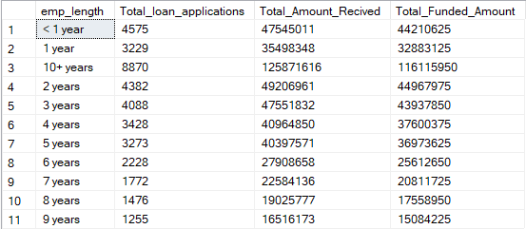

### Purpose behind Loan Applications

SELECT

purpose,

COUNT(id) AS Total_loan_applications,

SUM(total_payment) AS Total_Amount_Recived,

SUM(loan_amount) AS Total_Funded_Amount

FROM Bank_Loan_Data

GROUP BY purpose

ORDER BY COUNT(id) DESC

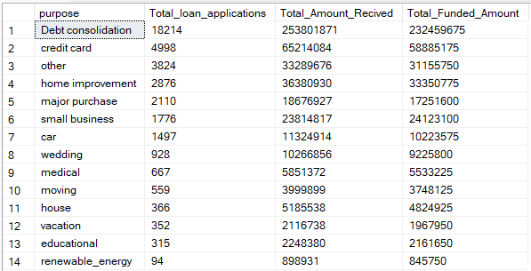

### Total Applications on basis of home ownership

SELECT

home_ownership,

COUNT(id) AS Total_loan_applications,

SUM(total_payment) AS Total_Amount_Recived,

SUM(loan_amount) AS Total_Funded_Amount

FROM Bank_Loan_Data

GROUP BY home_ownership

ORDER BY COUNT(id) DESC

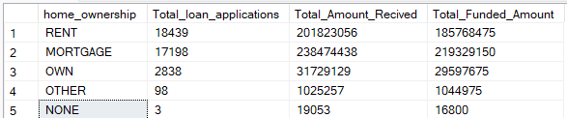

### Total Applications on basis of home ownership with more filters

SELECT

home_ownership,

COUNT(id) AS Total_loan_applications,

SUM(total_payment) AS Total_Amount_Recived,

SUM(loan_amount) AS Total_Funded_Amount

FROM Bank_Loan_Data

WHERE grade='A' AND address_state='CA'

GROUP BY home_ownership

ORDER BY COUNT(id) DESC

